Building, Calibrating and Testing a Quadcopter  
*A Systems Project*

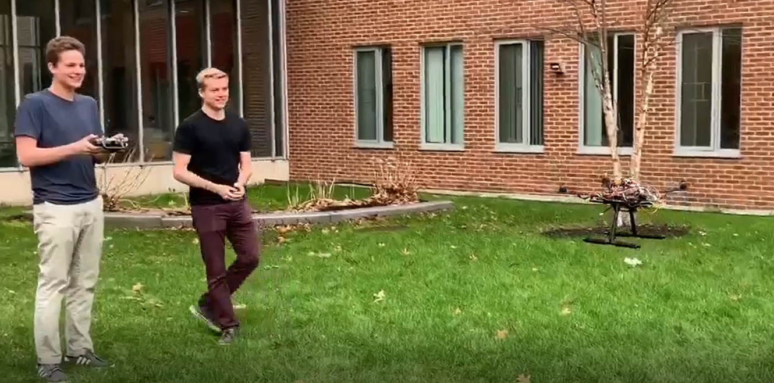

***Authors***  
*Thomas Collins  
Charlie Nitschelm  
Lucas Simmonds  
Ross Thyne*

Table of Contents

Table of Figures 3

Abstract 4

Introduction 4

Arduino 4

Electric Motors and Propellers 4

Electronic Speed Controllers 5

Transmitter and Receiver 5

Gyroscope 6

Power and Charging 7

Overall Engineering Problem 8

Experimental Set-Up 8

Dynamic Analysis 10

Overall Quadcopter Dynamics 10

Thrust Predictions 10

Electrical System Dynamics 11

Conclusions 12

Future Work 12

References 13

Appendix 13

Arduino Code 14

Setup, ESC Calibration and Flight Software 14

Peer Evaluation 14

# Table of Figures

Figure 1 - Arduino attached to the quadcopter to allow real-time control calculations for the quadcopter 4

Figure 2 - One of 4 of the electric motors and its attached propeller 5

Figure 3 - The electronic speed controller (ESC) to assist the Arduino to control the electric motor in real-time 5

Figure 4 - The Flysky transmitter used by the person controlling the quadcopter 6

Figure 5 - The receiver with 4 channel inputs for each motor need to have active control during flight 6

Figure 6 - The gyro pasted inside the frame of the quadcopter to provide active data on the pitch, roll and yaw of the quadcopter 7

Figure 7 - A 3-cell lipo battery mounted on an overhanging carriage allowing easy removal and charging 7

Figure 8 - The Tenergy battery charger to keep the Lipo battery fully charged before each flight 8

Figure 9 - Overall hardware set-up with little electronics attached 8

Figure 10 - Final quadcopter assembly with electronics connected 9

Figure 11 - Terrible quality still-frame of the quadcopter in action about to land on the grass 9

Figure 12 - A diagram showing the importance of opposite rotating propellers [1] 10

Figure 13 - The electrical dynamic schematic that was referenced for the quadcopter electrical system 4 11

# Abstract

The goal of this project is to create a quadcopter capable of flying with an active stabilization system with hand-held operation. An Arduino is utilized as the microcontroller that will facilitate all the active calculations needed to let all parts of the copter communicate and be controlled. A quadcopter’s dynamic behavior is difficult to model, and is closer than most flying machines to a satellite in orbit. An active, real-time gyro has been implemented into the design to constantly change our motors speed and its thrust delivery to keep it always directed in a stable direction.

# Introduction

Quadcopters are becoming a huge industry for their agility, speed and reliability. The cost of flight is cheap as rechargeable batteries are the only repeated costs for each flight/mission.

## Arduino

An Arduino was used to control all the devices on the quadcopter to enable active, stable flight which can be seen below in Figure 1.

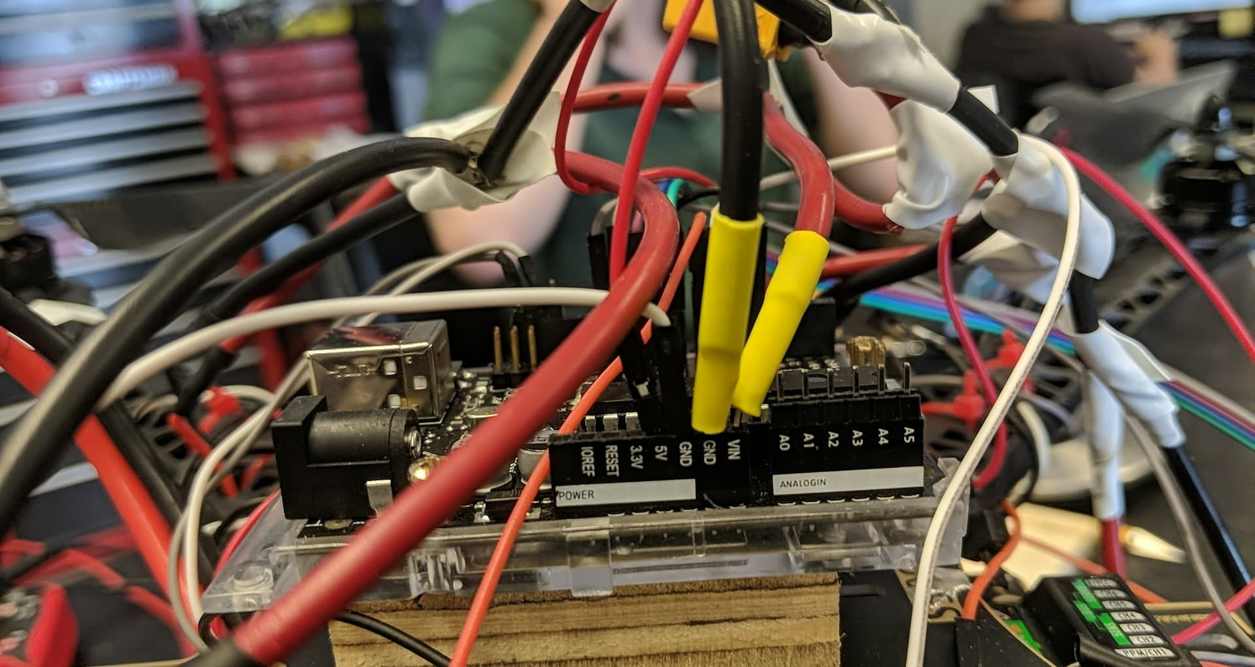

Figure 1 - Arduino attached to the quadcopter to allow real-time control calculations for the quadcopter

## Electric Motors and Propellers

Four electric motors and attached propellers were used to provide the thrust the quadcopter needs to be able to fly. The motors were purchased because they have been proven to work for a quadcopter similar to ours and can be seen below in Figure 2.

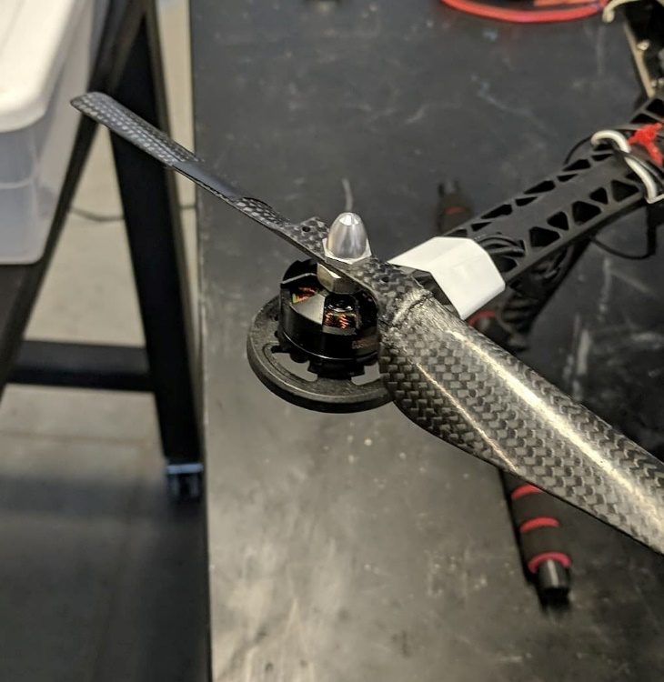

Figure 2 - One of 4 of the electric motors and its attached propeller

## Electronic Speed Controllers

Four electronic speed controllers were used to assist in the communication between the Arduino messages and the motor output which can be seen in Figure 3 below.

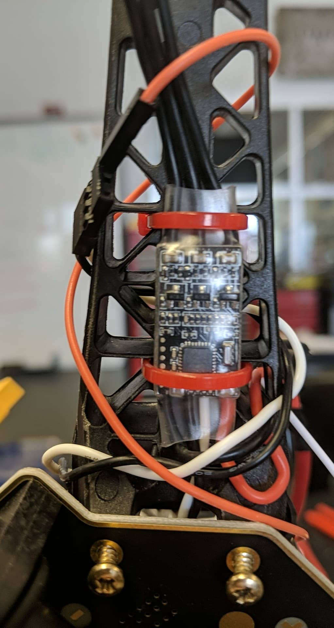

Figure 3 - The electronic speed controller (ESC) to assist the Arduino to control the electric motor in real-time

## Transmitter and Receiver

A transmitter and receiver were paired together to provide active signal input into the quadcopters Arduino that allows a person to control the quadcopter in real-time. These parts can be seen in Figure 4 and 5 below.

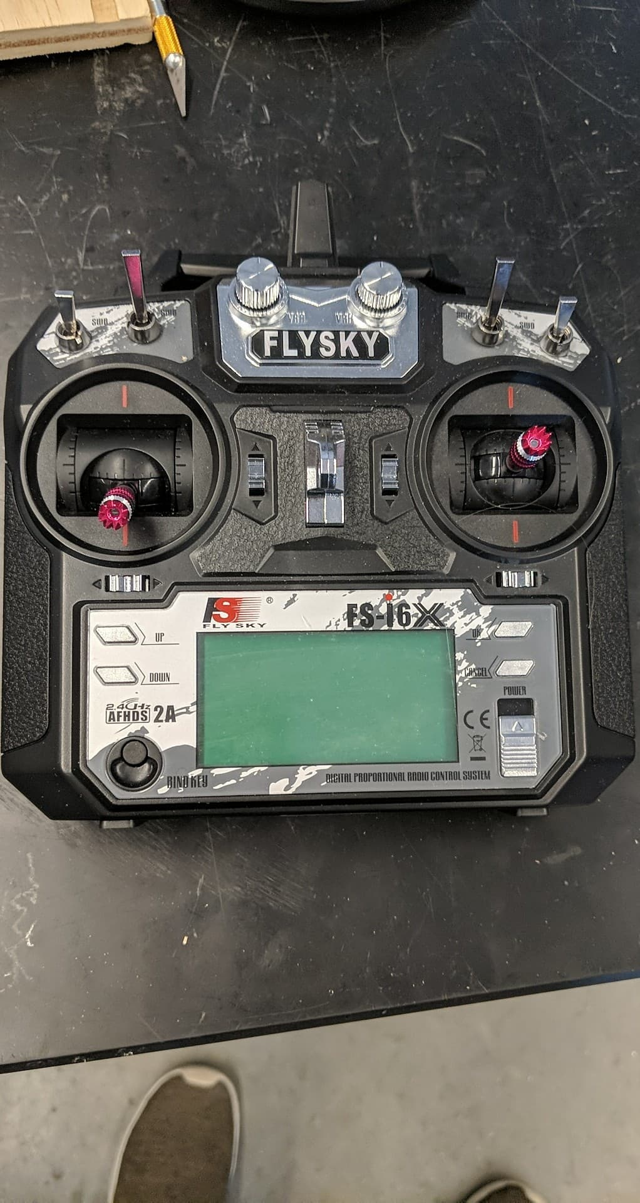

Figure 4 - The Flysky transmitter used by the person controlling the quadcopter

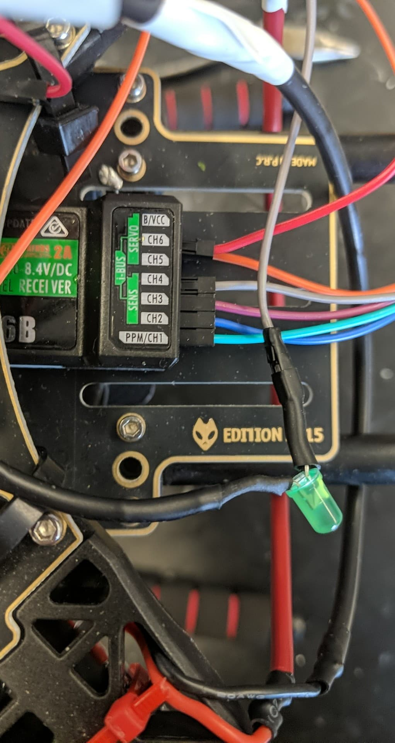

Figure 5 - The receiver with 4 channel inputs for each motor need to have active control during flight

## Gyroscope

A gyro was also attached perfectly into the middle of the quadcopter to provide real-time data on the positioning of the quadcopter in the roll, pitch and yaw directions. This active stabilization is crucial to the quadcopter as we always want the machine to be parallel with the ground. The gyro can be seen pasted at the bottom of our frame below in Figure 6.

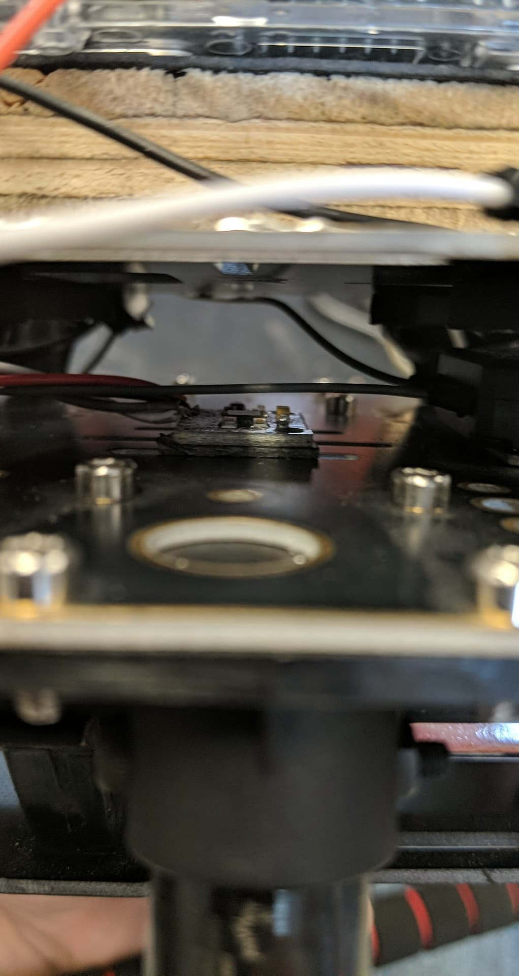

Figure 6 - The gyro pasted inside the frame of the quadcopter to provide active data on the pitch, roll and yaw of the quadcopter

## Power and Charging

Lastly, a three cell Li-Po battery and an accompanying battery charger were used to provide on-board power throughout its flight and future ones. These parts can be seen below in Figures 7 and 8 below.

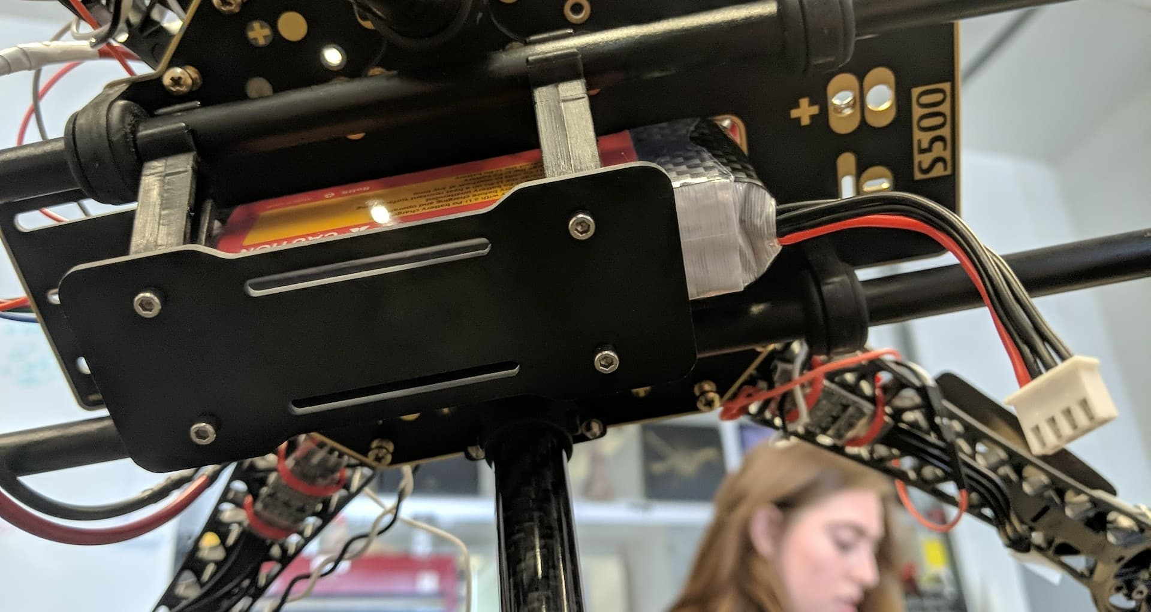

Figure 7 - A 3-cell lipo battery mounted on an overhanging carriage allowing easy removal and charging

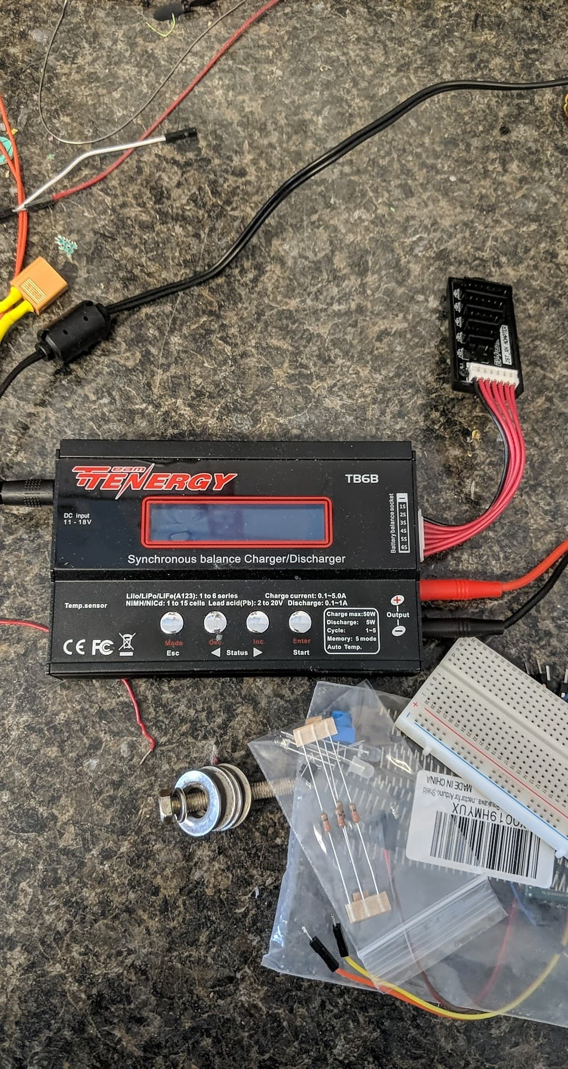

Figure 8 - The Tenergy battery charger to keep the Lipo battery fully charged before each flight

## Overall Engineering Problem

YMFC-AL, a website to help beginners build quadcopters, was of crucial assistance to the team for general build techniques, coding, calibration and overall assembly. A quadcopter is an incredibly hard, exciting field to enter, and the opportunity to work on it at a beginner level has enabled us to become excited for the future of the field.

# Experimental Set-Up

Figure 9 and 10 below show the quadcopter with the hardware set-up, and then the electronics connected, respectively. Given the complexity of the project, even the task of mounting the amount of parts needed for the success of the quadcopter was difficult.

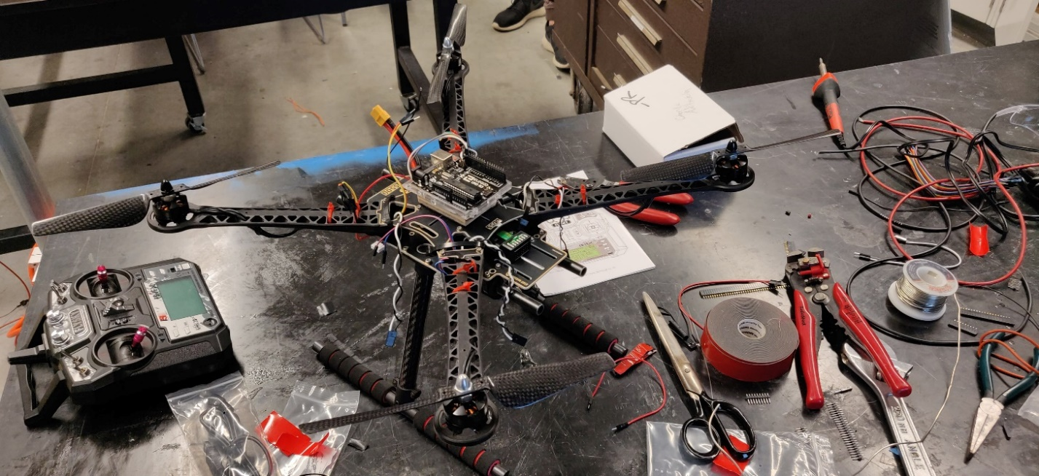

Figure 9 - Overall hardware set-up with little electronics attached

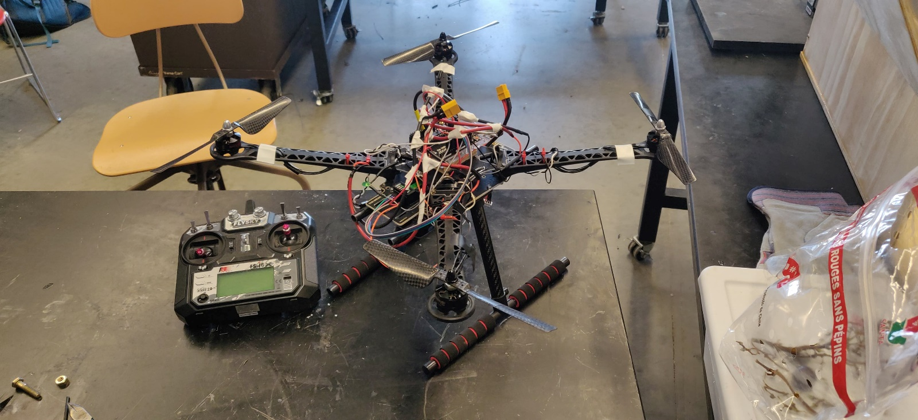

Figure 10 - Final quadcopter assembly with electronics connected

As the group did not have a lot of experience with the requirements of a quadcopter and overall electronic design, Andrew Masters within the Quadsat team at UNH was a huge help in giving us a better understanding of what needs to be done in a certain order and how to do it optimally. From the figures above, you can see that the wire management and overall look was not a concern, but will be fixed in the future as this project moves forward. The overall success of our project was based purely on the field experiments, but the look of a copter and its wire management is important.

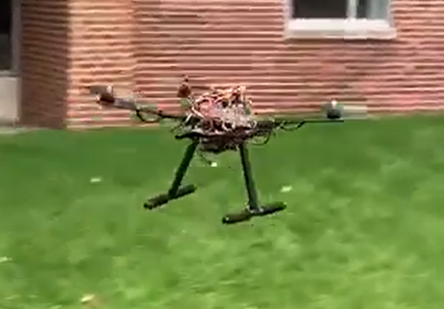

Figure 11 - Terrible quality still-frame of the quadcopter in action about to land on the grass

# Dynamic Analysis

## Overall Quadcopter Dynamics

Figure 11 below shows the standard configuration of a quadcopters dynamic set-up. The importance of opposite rotating propellers allow the quadcopter to have zero net angular momentum when all the propellers are going the same speed. The copter can then rotate easily by changing the net angular momentum the system.

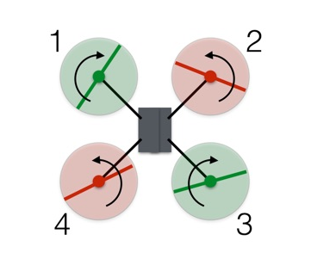

Figure 12 - A diagram showing the importance of opposite rotating propellers [1]

An Arduino and its accompanying user interface was implemented into the quadcopter to allow the control of the copter in flight and during landing. Using guides and example codes online [4], the majority of the coding needed to get the quadcopter off the ground was completed, but major debugging and calibration was needed to optimize its overall flight performance.

## Thrust Predictions

Given our materials that would be on the quadcopter, the appropriate motor and propeller combination could be determined. The overall weight of the quadcopter came out to be 940 grams, meaning that each propeller must be able to produce a thrust capable of carrying ¼ of that weight, plus a little more. Using the equation below, a predicted thrust could be calculated for certain diameter propellers attached to an electric motor with a certain max RPM.

$$Thrust=4.4*{10}^{-8}*RPM*\frac{d^{3.5}}{\sqrt{pitch}}*(4.23*{10}^{-4}*RPM*pitch)$$

By trying to be able to use some motors that were already had on hand, we knew a 6-inch diameter propeller could be used to achieve a thrust of each propeller. The motor RPM and assorted pitch values were then computed and printed an optimal blade that was easily found on amazon with fast delivery. From the equation, a thrust equal to lifting 315 grams of weight was computed, meaning enough to lift our quadcopter with four of them.

## Electrical System Dynamics

Figure 12 below details the complex wiring diagram that is needed to get our quadcopter to work with minor adjustments due to different parts we used. The 11.1 V lipo battery was used for all power requirements of the quadcopter. The majority of the hardware work on the quadcopter went into understanding, changing and optimizing the performance of this system.

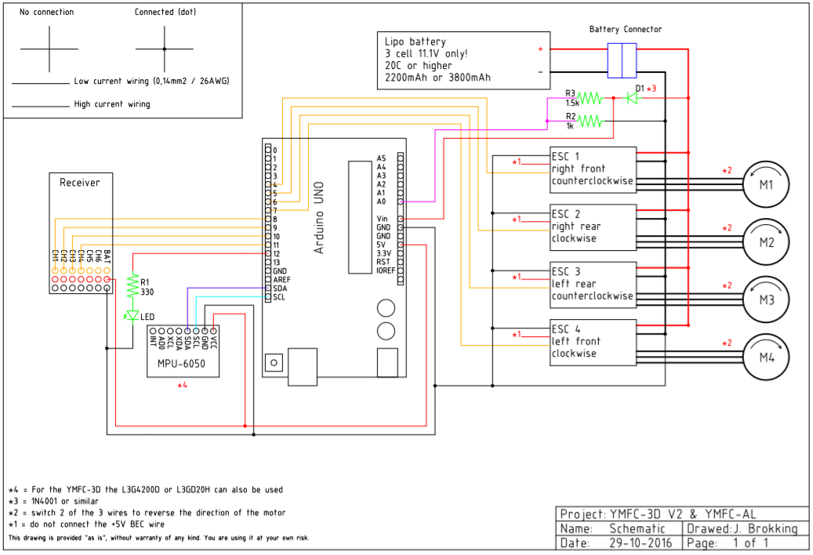

Figure 13 - The electrical dynamic schematic that was referenced for the quadcopter electrical system 4

# Conclusions

All of the evaluation of our project has been in-field testing to observe what is working, what is lacking, and what we could do to make it better, both in hardware, code and calibration. The first test to observe liftoff (3rd field test) showed correct active stabilization, which was a pivotal moment for us proving that we have moved in the right directions to achieve this moment.

## Future Work

In the event that we had more time and resources, some improvements could be made to the hardware and functionality of the quadcopter. A power distribution board (PDB) must be integrated into our system as it has not been used currently, and overtime, our motors will undergo fatigue and then fry its coils as the current is overloading each individual motor.

One of the first proposed expansions by our team would be to hardwire a camera to the quadcopter. This could be either through an SD card/USB operated camera that would continuously record and could be collected post flight, or through a stream capable camera that we could link to using a cellphone. For increased safety, LED lights, such as red in the rear of the copter, and or green at the front of the copter could be attached. Being able to very easily decipher the directional orientation of the quadcopter allows the operator to more easily respond with the proper inputs into the controller to get their desired output. This also makes the copter slightly more visible in the event that it is used around bystanders. The copters blades have the direct potential to cause bodily harm to people, so situational awareness is key.

For functionality and applications of the copter, there were thoughts to implement it into the UNH Students for the Exploration and Development of Space club to aid in its objectives. One thing that has been proposed is to equip a camera to the quadcopter as described above, and fly it to a predetermined height at a predetermined distance to catch footage of our future rockets launching from an aerial perspective. This not only would just be for entertainment and social media purposes, but also to give us a different optical perspective of the launch to be able to examine possible signs of roll or to evaluate our gimbaled guidance system qualitatively. There was also thought to hardwire and modify the quadcopter to allow it to tow a solid rocket booster to a predetermined height for testing. Once in the air, the solid booster could be dropped from the quadcopter, and using our gimbaling system could self-align itself and allow it to perform a suicide burn to land the booster safely and intact on the ground.

# References

[1] Allain, Rhett. “How Do Drones Fly? Physics, of Course!” Wired, Conde Nast, 3 June 2017, http://www.wired.com/2017/05/the-physics-of-drones/?fbclid=IwAR1RDHN6U61KR3H_6KAYHY1bCwACBJniGZOf6LyYH3sTLXyBXTlweeQoXdE.

[2] “Getting Started.” Arduino, 20 Oct. 2017, www.arduino.cc/en/Guide/HomePage.

[3] “Arduino Quadcopter.” Arduino Project Hub, 6 Aug. 2018, create.arduino.cc/projecthub/robocircuits/arduino-quadcopter-860741

[4] Brokking, J.M. “Project YMFC-AL - The Arduino Auto-Level Quadcopter.” Brokking.net - Project YMFC-AL - The Arduino Auto-Level Quadcopter - Home., 2017, www.brokking.net/ymfc-al_main.html?fbclid=IwAR1hj9yFag7j5ryasv4IKN0bs80sZClMVb4qZiyHqxiqaFeEgr1dTjY23Dg.

# Appendix

## Video Link

The final project video has been posted on YouTube and can be found at the following address:

## Arduino Code

### Setup, ESC Calibration and Flight Software

The link below has information on the software used and has not been attached because of its length. During configuration, the code needed to be altered to fit the various parts we had compared to ones that the build used.

<http://www.brokking.net/ymfc-al_downloads.html>

## Peer Evaluation

We, the members of the Quadcopter project, pledge that all of us contributed equal amounts to the project and this report.

**Thomas Collins**

____________________________________________________________

**Charlie Nitschelm**

____________________________________________________________

**Lucas Simmonds**

____________________________________________________________

**Ross Thyne**

____________________________________________________________